12/18/2025
Nhat Ha Pham

Process and Safety Group Assignment
SCARA Robot

Table of Contents
Process 2
Functionally analyzed process of the project 2
Interaction between Parts/Modules 2
Visualization Quality 3
Main Function Flowchart 3
Sub Function Flowchart 3
Discussion with Clients 3
Safety 3
Definition of Performance Level 3
Risk Assessment 3
Self-Evaluation 3
Group Works 3
Future Improvement 4

Process

Functionally analyzed process of the project
To analyze the functionality and the process of the project, a node tree diagram was made.
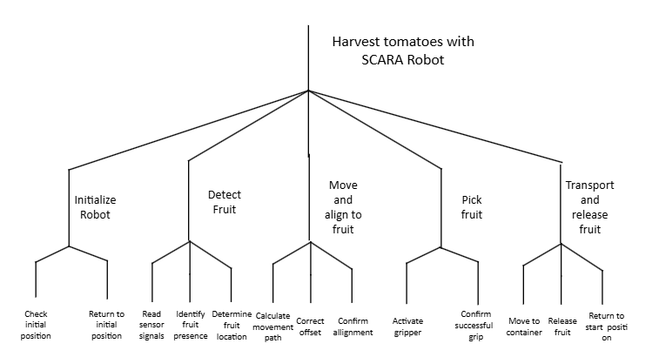
Figure 1, Node tree diagram about functionality of the project.

Interaction between Parts/Modules
The figure below illustrates how the hardware components connected and communicate to the other.
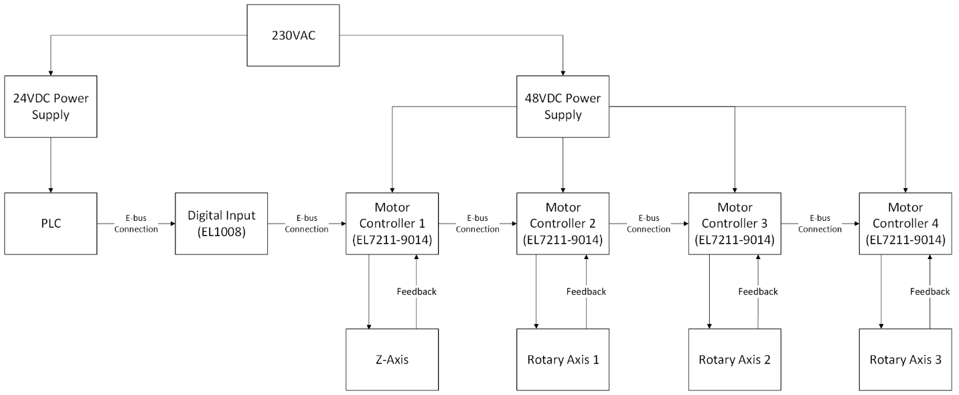
Figure 2, Diagram shows how the hardware parts connected to each other.

Visualization Quality

Main Function Flowchart
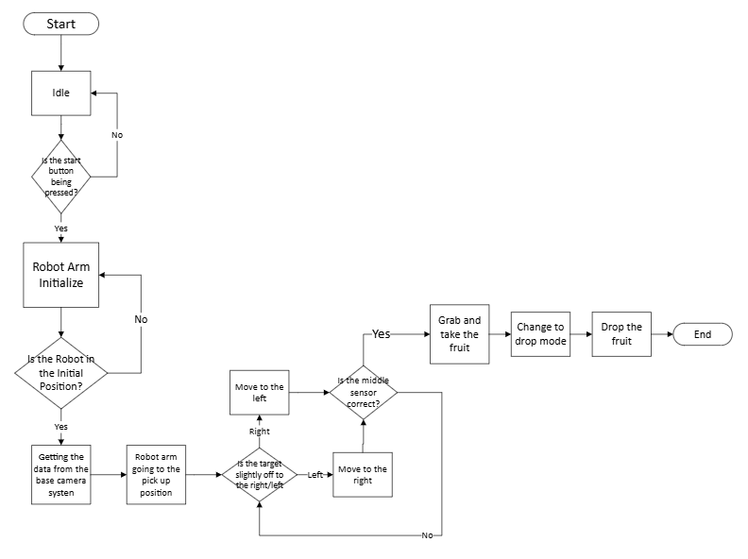
Figure 3, Main Function flowchart of the Project.

Sub Function Flowchart

Discussion with Clients
A poster included the progress of the project, and the future plans of the project was made to discuss with the customer.
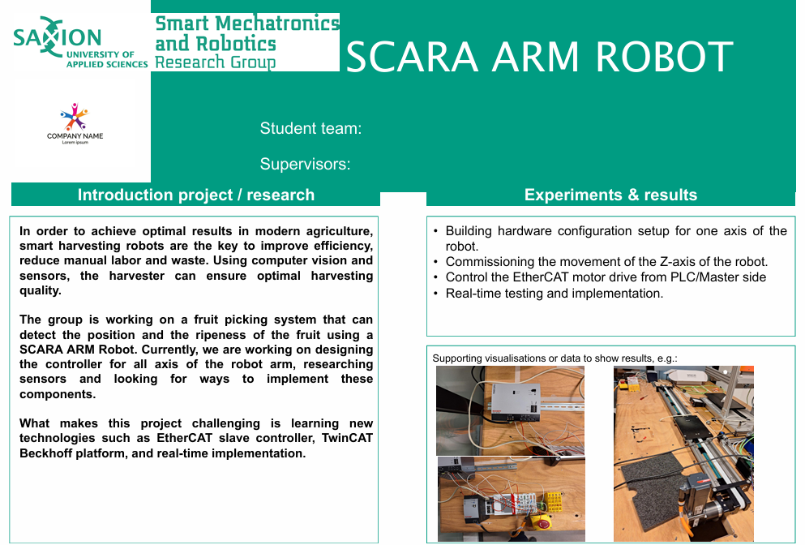
Figure 4, Poster to discuss with the clients.
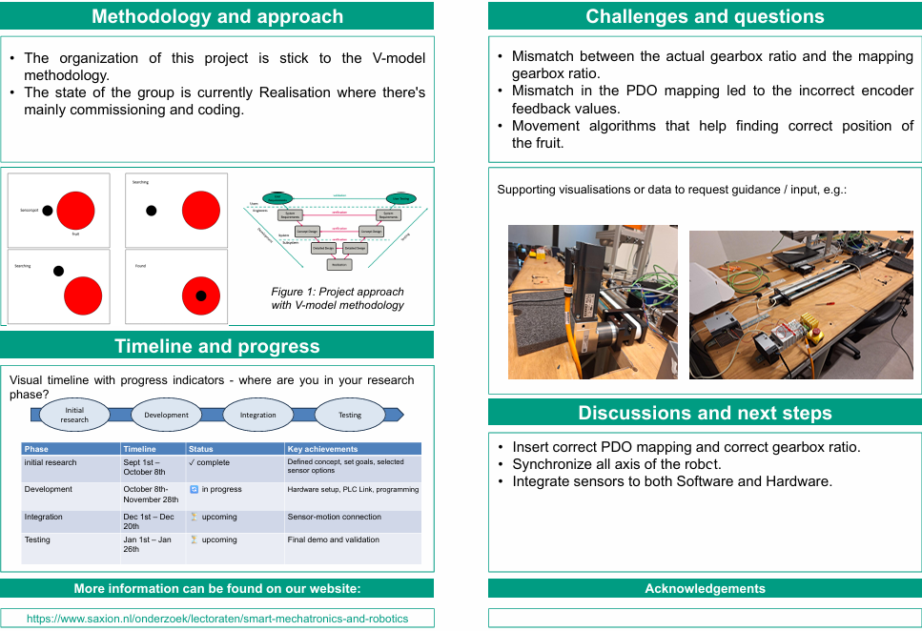
Figure 5, Poster to discuss with the clients

Safety

Definition of Performance Level

Risk Assessment

Self-Evaluation

Group Works
- The team members need to be more active.
- The tasks can be clearer and more equal.
- Stop playing games during working hours.

Future Improvement

